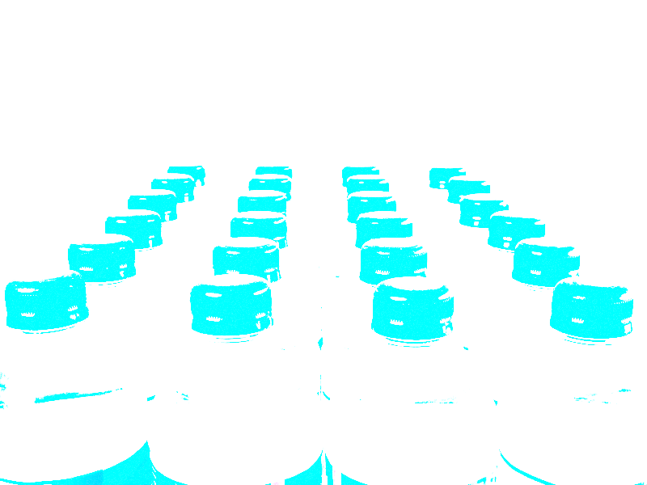
Bottled Water Activity

The bottle water industry is growing at a rapid rate around the world. In Europe, estimated consumption is 27.7 billion litres. The US consumes about 11 billion litres per year. There are now more than 100 different types of bottled water, available in Australia. Take a look at three different types of bottled water currently available. Complete the following for each brand selected:

Name of bottled water
Owner of company marketing the water
Where is it bottled?
Type of water (purified, spring etc)
Analysis of the water
Cost per litre
Look closely at the packaging and design. What message does it give?
Carefully examine the design and label of the product. What image are they creating?

Name of bottled water
Owner of company marketing the water
Where is it bottled?
Type of water (purified, spring etc)
Analysis of the water
Cost per litre
Look closely at the packaging and design. What message does it give?
Carefully examine the design and label of the product. What image are they creating?

Name of bottled water
Owner of company marketing the water
Where is it bottled?
Type of water (purified, spring etc)
Analysis of the water
Cost per litre
Look closely at the packaging and design. What message does it give?
Carefully examine the design and label of the product. What image are they creating?

